Dissipation of Quasiclassical Turbulence in Superfluid ⁴He

D. E. Zmeev^{1,2}, P. M. Walmsley¹, A. I. Golov¹, P. V. E. McClintock², S. N. Fisher² & W. F. Vinen³

¹School of Physics and Astronomy, The University of Manchester, Manchester M13 9PL, UK
²Department of Physics, Lancaster University, Lancaster LA1 4YB, UK
³School of Physics and Astronomy, University of Birmingham, Birmingham B15 2TT, UK

Abstract We compare the decay of turbulence in superfluid ⁴He produced by a moving grid to the decay of turbulence in the same channel created by either an impulsive spin-down to rest or by intensive ion injection. In all cases the vortex line density L at late time t decays as L ∝ t^{-3/2}. Below 0.8 K, the spin-down turbulence maintains initial rotation and decays slower than grid turbulence and ion-jet turbulence. This is presumably due to the decoupling of the superfluid component from the normal one at large length scales at low temperatures, thus changing its effective boundary condition from no-slip to slip.

In superfluid helium, quantum-mechanical constraints impose quantization of velocity circulation (in small quanta of h/m = 1.0 × 10⁻³ cm²s⁻¹). At typical experimental length scales, such as centimeters, when the velocity circulation round vortical structures typically amounts to many quanta of circulation, this discreteness can be neglected. The coarse-grained flow thus evolves similarly to that in classical fluids at high Reynolds numbers, especially thanks to the truly zero shear viscosity of superfluid helium. At smaller length scales, where the existence of quantized vortex lines comes into play, their individual dynamics (reconnections, generation of Kelvin waves) feeds the flow energy into dissipative processes such as sound emission. These processes are of interest because they allow the transfer of flow energy from classical to quantum degrees of freedom. Our aim was to measure the rate of dissipation in different turbulent flows and to compare it with existing theoretical expectations.

We will review experiments, performed in Manchester, on the decay of quantum turbulence in superfluid ⁴He generated using different techniques for forcing at large length scales. The main focus is on the limit of zero temperatures. In this regime, the dynamics of the vortex lines spans length scales from the size of container down nearly to atomic scale. Studying the free decay allows the rate of dissipation to be quantified. Three different means of generating turbulence will be discussed (each having an analogue in classical turbulence, thus allowing comparison with classical results):
- an unsteady rotation of a square-shaped container allows the creation of anisotropic turbulence – which decays more slowly [1, 2, 3];
- an immersed jet created by a current of injected electrons [3];
- a towed grid, which produces turbulence that is nearly homogeneous and isotropic [3].

The experimental techniques are described elsewhere [4,5]. The vortex line density L was measured by scattering micron-sized charged vortex rings off the vortex tangle under investigation. A phenomenological model [3,6] explains the decay law, L ∝ t^{-3/2}, of quasiclassical turbulence if its integral length scale is constant in time — being set by the size of the container. The prefactor in this formula reflects the balance between the rates of injection of energy at the integral length scale and of its absorption via the quantum cascade towards the shorter dissipative length scales. As one can see in Fig. 1, the turbulence generated by an impulsive spin-down from uniform rotation decays much more slowly than the turbulence created by a towed grid in the same container. We have evidence that the spin-down turbulence retains some angular momentum of its original rotation and is hence anisotropic and also, perhaps, inhomogeneous. This is due to the fact that, at temperatures below about 1K, the coupling of the vortex tangle to the container walls, usually mediated by the viscous gas of thermal excitations, becomes inefficient. As a result, the angular momentum of rotation survives for long time [7]. In contrast, the grid-generated turbulence is expected to be more isotropic and homogeneous. This experiment therefore sets the benchmark value for the decay rate of homogeneous and isotropic quantum turbulence in the limit of zero temperature.

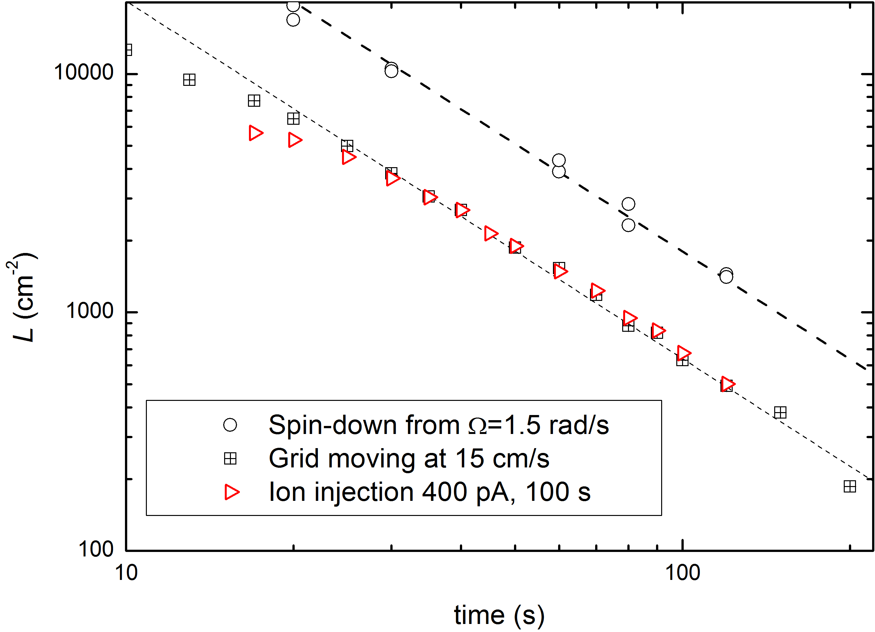

Figure 1. An example of experimental data for a channel of rectangular cross-section, 1.8cm×1.7cm, T=0.09K [3]. Lines show L ∝ t^{-3/2} dependence.

This work was supported through the Materials World Network program by the Engineering and Physical Sciences Research Council (Grant No. EP/H04762X/1). P.M.W. is indebted to EPSRC for a Career Acceleration Fellowship (Grant No. EP/I003738/1).

References

[1] P. M. Walmsley, A. I. Golov, H. E. Hall, A. A. Levchenko and W. F. Vinen, Phys. Rev. Lett. 99: 265302, 2007.
[2] Paul Walmsley, Dmitry Zmeev, Fatemeh Pakpour, and Andrei Golov, PNAS 111: 4691, 2014.
[3] D. E. Zmeev, P. M. Walmsley, A. I. Golov, P. V. E. McClintock, S. N. Fisher, and W. F. Vinen (in preparation).
[4] P. M. Walmsley, A. I. Golov, H. E. Hall, W. F. Vinen, and A. A. Levchenko, J. Low Temp. Phys. 153: 127-139, 2008.
[5] D. E. Zmeev, J. Low Temp. Phys. 175: 480, 2014.
[6] S. R. Stalp et al., Phys. Rev. Lett. 82: 4831, 1999.
[7] J. J. Hosio et al., Nature Comm. 4: 1614, 2013.

